JUNE 9, 2026
VIRTUAL
12 PM – 4:30PM EST

12:00pm – 12:10PM Welcome and Introduction

12:10PM – 1:10PM Session #1

Session Title: Master the Moment: Bridging the Gap Between Instinctive Reaction & Intentional Leadership | 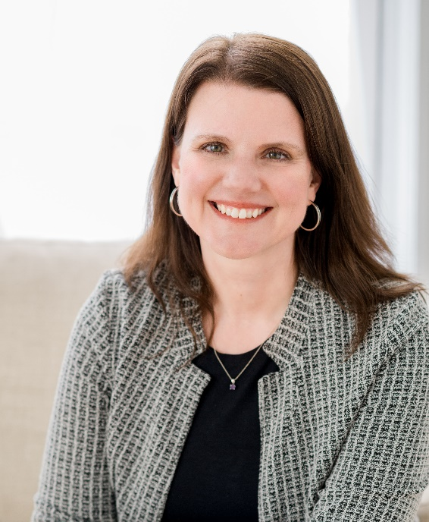
Session Speaker: Kim Meninger

Company: Executive Career Success, LLC d/b/a Kim Meninger

1 CPE / Personal Development / Basic
PRESENTATION DESCRIPTION:
In today’s climate of relentless change, rising complexity and increasing pressure, even the most experienced leaders can struggle to show up as their best selves. When the stakes are high, many default to reactive patterns like overthinking, over-functioning or overcompensating. These behaviors may feel productive in the moment, but over time they erode trust, limit innovation and weaken performance.
As the pressure continues to rise, leaders need practical strategies to close the gap between their best selves and the version of themselves that emerges under stress. This interactive session introduces the LEADS framework, an actionable system that helps leaders shift from instinctive reaction to intentionality in the moments that matter most.
LEARNING OBJECTIVES:
Upon completion of this session, participants will be able to identify and explain the fundamental components of Medicare, including eligibility requirements, enrollment timelines, and the distinctions between Parts A, B, C, and D. They will develop the ability to assess how different plan types impact coverage, cost, and access to care. Participants will also learn to recognize common enrollment pitfalls, understand coordination with other insurance types, and apply this knowledge to guide informed, compliant Medicare decisions for themselves or their clients.
PRESENTER BIOGRAPHY:
Kim Meninger is a leadership coach, consultant and keynote speaker who helps leaders lead with greater confidence and steadiness under pressure. Kim focuses on the internal dynamics that shape how people show up at work, including emotional regulation, self-trust and sustainable performance. She supports leaders in moving beyond reactivity so they can act with intentionality and align with their values.
Kim previously held leadership positions managing strategic relationships at EMC and Monster. She holds a BA in psychology and an MBA from Boston College. She is also an ICF Professional Certified Coach with certifications in confidence, career, executive and leadership development coaching. Kim writes weekly for Forbes, hosts the Impostor Syndrome Files podcast and leads a weekly Leading Humans discussion forum, which is free and open to all.

1:10PM – 1:15PM Break

1:15PM – 2:15PM Session #2

Session Title: Beyond the To-Do List: Mental Load, Caregiving, and What It’s Costing Women at Work | 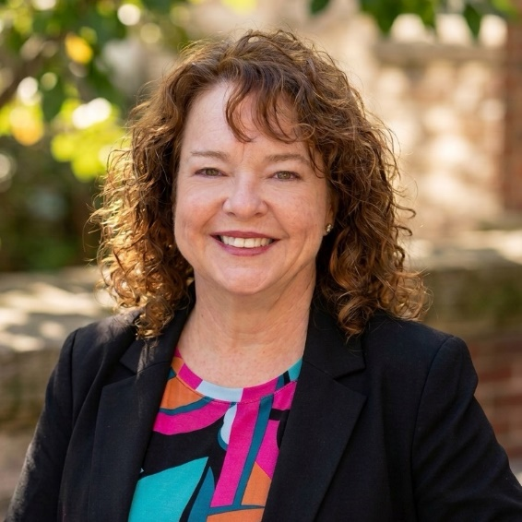
Session Speaker: Bonnie Buol Ruszczyk
Company: Accounting MOVE Project, bbr companies
1 CPE / Personnel/Human Resources / Overview

PRESENTATION DESCRIPTION:
Women often carry a disproportionate share of mental load, the ongoing, invisible work of managing responsibilities, anticipating needs, and keeping everything moving at work and at home. For many, caregiving responsibilities add another layer that doesn’t pause during the workday.
This session explores how mental load shows up in real ways for women (and some men) and how it affects well-being, performance, and career advancement. We’ll also examine how caregiving intersects with workplace expectations and leadership pathways, and share practical strategies to better recognize, manage, and redistribute these demands.
LEARNING OBJECTIVES:
- Define mental load and explain how it uniquely impacts women in the workplace
- Recognize how caregiving responsibilities intersect with mental load and influence women’s career experiences and advancement
- Identify how workplace expectations and gender dynamics contribute to the uneven distribution of mental load
- Apply practical strategies to better manage, redistribute, and reduce mental load for themselves and other women
- Evaluate ways organizations can better support women, particularly those with caregiving responsibilities
PRESENTER BIOGRAPHY:
Bonnie Buol Ruszczyk (like “rustic” without the “t”) is the founder of BBR Companies LLC, where she provides CMO-level marketing strategy for professional services firms; owner of the Accounting MOVE Project, the profession’s leading source of data and guidance on advancing women and underrepresented talent in accounting; and co-owner of Rally Rounds, which facilitates mastermind groups for accounting growth professionals.
Across all of these roles, Bonnie’s work centers on helping firms uncover and communicate their differentiators, build inclusive, high-performing cultures, and create the support structures professionals need to grow and lead.
She holds an MBA with a marketing concentration from Georgia State University and a Bachelor of Arts in journalism, public relations, and French from Troy University. She also earned a Diversity & Inclusion Certificate from Cornell University and continues advanced coursework to deepen her expertise in talent strategy and culture.
Bonnie quite literally wrote the book on digital marketing for accounting firms, Take Your Marketing Online: Proven Ways to Grow Your Firm in the Digital Age, published at the request of the AICPA. She also contributed to Bridging the Gap: Strengthening the Connection Between Current and Emerging Leaders and is a frequent contributor and source for industry publications.
She has been named one of Accounting Today’s Top 100 Most Influential People six times (most recently in 2025), is a Hall of Fame member and former Volunteer of the Year for the Association for Accounting Marketing, and was recognized as one of CPA Practice Advisor’s Most Powerful Women in Accounting.
Before launching BBR Companies in 2009, Bonnie held leadership roles in Silicon Valley and global media, including serving as public relations director for Sportbrain (a precursor to Fitbit) and international marketing manager for Turner Broadcasting, where she helped launch TNT and Cartoon Network in Asia. These experiences shaped her expertise in growth strategy, branding, and culture within professional services.
She is also a board member of the Accounting and Financial Women’s Alliance, a founding member of the Atlanta Independent Women’s Network (AIWN), a former board member of the Association for Accounting Marketing, and a member of the CPA Consultants’ Alliance.

2:15PM – 2:25PM Break

2:25PM – 3:25PM Session #3

Session Title:  Undoing the Queen Bee Mentality Theme: Breaking cycles of competition, gatekeeping, and scarcity among women leaders. | 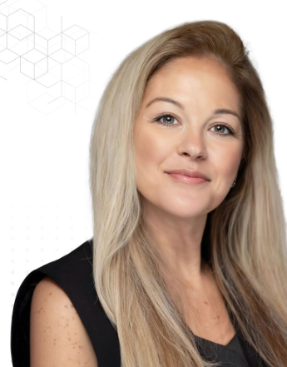
Session Speaker:
Rachel Anevski, PHR, SHRM-CP
Company:
Winding River Consulting
1 CPE / Personal Development / Basic
PRESENTATION DESCRIPTION:
This one-hour session, Undoing the Queen Bee Mentality, invites women leaders to examine and dismantle the patterns of competition, gatekeeping, and scarcity that can quietly shape how women relate to one another in professional spaces. Through guided discussion, participants will explore the origins of the "Queen Bee" phenomenon, recognize how fear and insecurity drive scarcity-based leadership, and reflect on the personal and collective cost of internalized competition. The session emphasizes practical, collaborative alternatives rooted in self-awareness, accountability, and vulnerability, equipping participants to leave with a clear, actionable commitment, one behavior to release and one to strengthen, so they can lead in ways that lift other women rather than limit them.
LEARNING OBJECTIVES:
Participants will:
- Understand the “Queen Bee” phenomenon
- Identify scarcity-based leadership behaviors
- Explore the impact of internalized competition
- Learn collaborative leadership alternatives

PRESENTER BIOGRAPHY:
As Managing Director of Learning and People, Rachel Aneveski partners with public accounting firm leaders to strengthen leadership pipelines, improve retention, and develop future business leaders—not just technical experts.
With more than 20 years of experience inside CPA firms and as an external advisor, Rachel brings a practical, insider-informed perspective to leadership and talent challenges across the profession. Her work focuses on leadership development, succession planning, organizational culture, and change leadership, helping firms grow while staying deeply committed to their people. Rachel began her career in public accounting operations and human resources and later worked within a national firm during a period of rapid growth and early private-equity transformation. She holds a master’s degree in organizational behavior and a doctorate in organizational leadership, and is the co-author of Accounting For Times: Evolve or Dissolve and the author of Train Your Successor ™: Strategies to Train and Retain Future Leaders in Public Accounting Firms (2025).

3:25PM – 3:30PM Break

3:30PM – 4:30PM Session #4
Session Title: Chapter Leader Panel Discussion
Session Speaker: Moderated by Chelsea Sowers, Stephanie Sommers
Company: Accounting & Financial Women’s Alliance
1 CPE / Personal Development / Basic

4:30P – 4:35pm CLOSING REMARKS

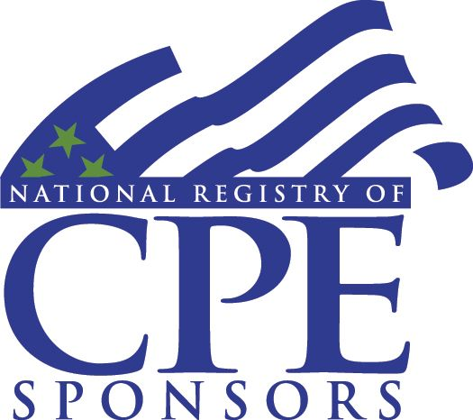 | AFWA is registered with the National Association of State Boards of Accountancy (NASBA) as a sponsor of continuing professional education on the National Registry of CPE Sponsors. State boards of accountancy have final authority on the acceptance of individual courses for CPE credit. Complaints regarding registered sponsors may be submitted to the National Registry of CPE Sponsors through its website: www.NASBARegistry.org.

