FOR IMMEDIATE RELEASE
June 14, 2023
CONTACT
Erinn Donnell, Communications Manager
406.442.7301
erinn@montana.cpa

THE MONTANA SOCIETY OF CPAS ANNOUNCES 2023 TOP AWARD WINNERS

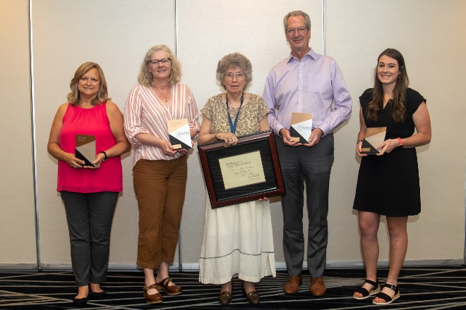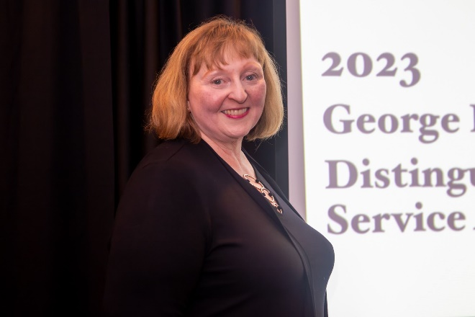

HELENA, MT – The Montana Society of CPAs (MTCPA) is proud to announce the recipients of the organization’s top awards at their recent 110th Annual Conference, held in Missoula June 8-9, 2023.

MTCPA was proud to recognize Ann Deegan, CPA, with the Society’s highest honor: the 2023 George D. Anderson Distinguished Service Award. This award recognizes a member who has enhanced the profession, as well as serving the public with distinction.

Ann is employed at Summers McNea & Co. PC in Billings and continues to be active in a variety of organizations – including the Accounting Financial Women’s Alliance (AFWA), where she has been a dedicated member for over 35 years, not only in her local Billings Chapter, but on the National level as well. “Ann has demonstrated exceptional leadership qualities and is looked upon as a very well-respected member in all of her professional and extracurricular activities.”, said Allen Lloyd, MTCPA’s Executive Director.

Terri Herron, PhD, CPA was awarded the Jack Kempner Outstanding Educator Award. The recipient of this award is one who is distinguished for excellence in classroom teaching and motivating students, educational innovation and contributions to the accounting profession, as demonstrated by their active involvement in professional activities.

Dr. Herron’s nomination states, “Terri teaches Auditing at the University of Montana and was my professor many years ago. I credit her solely for passing the Auditing section of the CPA exam. She works with the community to showcase her students with an educational event every December, where there is always so much to learn! It is not out of sorts to say that Terri is one of the best professors at the U."

The Outstanding CPA in Industry Award was presented to Carrie Jensen, CPA, CGMA. This award recognizes the achievements of individual CPAs employed in business, industry, nonprofit and government (BING) – who is making significant contributions to the growth and enhancement of the profession, providing leadership-by--example and commitment within their employment, and inspiring and motivating others for growth and development. Carrie owns and operates Yarn & Honey in Great Falls.

Merna Lechman, CGMA, was the recipient of the Outstanding Volunteer Award. This award represents an important opportunity to focus recognition on volunteers who achieve excellence in leading MTCPA committees, task forces, and working groups. The support for these awards comes from the Society’s tradition of serving the profession and is intended to recognize outstanding examples of leadership and achievement. Merna has recently retired after many years at Montana Municipal Interlocal Authority (MMIA) in Helena.

Community service is a vital part of any community and MTCPA is proud to have members that provide their time, expertise, and manpower to help organizations around our communities - and in turn, make Montana a better place to live. John Jacobsen, CPA, winner of this years’ Community Service Award, "… has consistently dedicated his professional expertise and extensive personal time to community non-profit boards and professional services. John has been actively involved in innumerable volunteer and board roles throughout his long career as a Montana CPA." John is employed at Eide Bailly LLP in Billings.

Up-and-coming CPAs are the heart of the profession and absolutely imperative in the growth of the profession as a whole. The Outstanding Young CPA Award is to recognize the talent of young Montana CPAs and for their significant accomplishments within MTCPA or a local MTCPA Chapter. Jaylin Kenney, CPA, was awarded this distinction at the 110th Annual Conference. Jaylin is employed at JCCS PC in Helena.

All of the MTCPA Award recipients embody dedication and determinism in the accounting field. MTCPA Executive Director, Allen Lloyd, states “We are proud to have these committed members who not only are bettering the profession, but also the communities they live and work.”

The Montana Society of CPAs is a professional association comprised of nearly 1,600 members worldwide. The mission of the Montana Society of Certified Public Accountants is to inspire, empower and impact members to achieve professional excellence.

###

