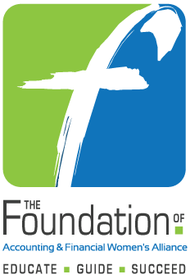

2022-2023 National and Local Chapter Dues

Reimbursement Application

For AFWA Members due to a Natural Disaster

Submit Application to The Foundation
Within 1 year of Renewal

PLEASE READ AND COMPLETE THIS APPLICATION CAREFULLY!
THE FOUNDATION WILL CONSIDER ONLY COMPLETE APPLICATIONS.

National and Chapter Dues Reimbursement for Members due to Natural Disaster

Purpose: To assist active members with national and local chapter dues reimbursement
Criteria: Applicants
- Must be an AFWA member
- Must have been an active member for a minimum of one year prior to application
- Must have experienced a natural disaster in the city in which they are an AFWA member
- May be reimbursed for a maximum of two consecutive years with reapplication required for the second year

- APPLICATION INFORMATION
AFWA Membership (chapter or member at large)
Date Applicant Joined AFWA

Date of Renewal

Date of Scholarship Application
Name of Applicant

THE APPLICATION FORM AND ALL ACCOMPANYING DOCUMENTS SHOULD BE ENTERED HERE*: https://www.afwa.org/scholarships/submissions/
*If a field is not applicable, please enter n/a

- PERSONAL DATA (Contact information where applicant may be reached)
Address
City/State/Zip
Telephone E-mail Address

- Date and type of natural disaster ________________________________________________
  - Please describe the natural disaster and how it has affected you ____________________________________________________________________________________________________________________________________________________________________________________________________________________________________________________________________

- AFWA Activities (those that you have participated in)

Please list or describe any relevant information regarding your AFWA participation and leadership. For example: (1) Served two years as Program Chair for the chapter – 2016-2018. (2) Served on the National Board as Secretary (one year) and Treasurer (one year) – 2018-2020. (3) Served on the Credentials Committee at the 2020 Annual Meeting.

Award notifications will be made within 60 days of receipt of application. Please do not call or email requesting the status of your application. Application submission does not guarantee a reimbursement.

