

**FOR IMMEDIATE RELEASE Media Contact**:

Debi Williams

Director of Operations

Accounting & Financial Women’s Alliance

P: 859.219.3578 | [deborah.williams@afwa.org](mailto:%2520deborah.williams@afwa.org)

Joanne Cleaver

President

Wilson-Taylor Associates, Inc.

P: 980.224.8781 | Cell: 414.232.3181 | jycleaver@wilson-taylorassoc.com

**Social Media**

@AFWANational

**New Practices, New Possibilities**

*2020 Accounting MOVE Project will outline new career paths for women opened by Firms’ expansions into new practices.*

*Firms of all sizes are invited and encouraged to participate the annual survey that measures the progress of women in the accounting industry.*

Lexington, KY, October 20, 2019

From artificial intelligence to data security audits, accounting and advisory firms are rapidly expanding into new practices. As they do, they create new career opportunities that open new ways to develop, retain, and advance women.

The [2020 Accounting MOVE Project](https://www.wilson-taylorassoc.com/move/accounting) will explore emerging career paths that bring both new ways to propel women to leadership and, in some cases, new obstacles.

Firms of all sizes are invited and encouraged to participate. Registration is open at [wilson-taylorassoc.com](https://www.wilson-taylorassoc.com/move/accounting) through December 18, 2019. In addition to reporting findings from this survey, the MOVE Project will produce the 2020 list of the top public accounting firms for women and top equity leadership firms.

“Women want to invest in careers that offer flexible, sustainable growth,” said Joanne Cleaver, president of Wilson-Taylor Associates, Inc., the content and editorial services firm that designs and manages the MOVE Project. “The 2020 Accounting MOVE Project report will equip firm leaders and individual women to align their mutual investment for long-term personal and firm success.”

The leading CPA firms that sponsor the Accounting MOVE Project are experiencing these changes themselves.

“Our industry is rapidly evolving and with change, opportunity is created. Exploring career opportunities perceived as risky or outside of the typical career path can be daunting, but with the support of the firm and those around them, it can be a game-changer for an individual,” said Jennifer Wyne, executive director of human resources for Moss Adams, founding sponsor of the Accounting MOVE Project.

“An accelerated client demand for specialized solutions to increasingly complex business problems is driving rapid growth in Advisory – and with it, an expansion of leadership opportunity in accounting firms,” said Risa Lavine, principal and chief of staff at CohnReznick, national sponsor. “At CohnReznick, we have seen this first-hand, where many of our Advisory practices are led by women. Growth in Advisory is also driving better teaming across the firm, providing more inclusive opportunities for the development of women at all levels.”

Members of the Accounting and Financial Women’s Alliance, the nonprofit partner of the Accounting MOVE Project, are eager to open new ways for women and firm growth. “We’re seeing changes in the accounting industry like never before. Technological advancements are creating new career opportunities, new options for flexibility and collaboration, and a lot of new questions. Our members are asking how these advancements are going to help – or hurt – their careers. I’m excited to see what answers will be uncovered through this year’s MOVE Project research,” said AFWA executive director, Cindy Stanley.

Prior MOVE Project reports may be found at <https://www.wilson-taylorassoc.com/move/accounting>. Highlights of the 2019 Accounting MOVE Project will be presented at the [AFWA’s annual conference](mailto:https://www.afwa.org/women-who-count/schedule/) on October 22.

The MOVE Project is supported by founding sponsor Moss Adams, national sponsor CohnReznick, and administrative fees from participating firms.

MOVE is making a real difference in the profession and has positioned CPA firms as innovators in the business world. Look no further than [MOVE mentions](http://wilson-taylorassoc.com/media) in the *CPA Practice Advisor, Harvard Business Review, Financial Times, Parade,* and other publications to see how MOVE Project firms are leading the national conversation about advancing women.

Registration Link >> https://www.wilson-taylorassoc.com/move/accounting

**Con’t - About the Accounting/MOVE Project Partners**



**Moss Adams** brings more West to business. More than a location, it’s a way of doing business in which innovation thrives and optimism abounds. At Moss Adams, we’re excited by the greatness of possibility and the extraordinary potential for companies and individuals to prosper. With more than 3,200 professionals across 25-plus locations in the West and beyond, we provide the world’s most innovative companies with specialized accounting, consulting, and wealth management services to help them embrace emerging opportunity. Visit www.mossadams.com to discover how Moss Adams is bringing more West to business. For more information, visit www.mossadams.com.



As a leading advisory, assurance, and tax firm, CohnReznick helps forward-thinking organizations achieve their vision by optimizing performance, maximizing value, and managing risk. Clients benefit from the right team with the right capabilities; proven processes customized to their individual needs; and leaders with vital industry knowledge and relationships. Headquartered in New York, NY with offices nationwide, the firm serves organizations around the world through its global subsidiaries and membership in Nexia International. For more information, visit [www.cohnreznick.com](https://www.cohnreznick.com/).​



The Accounting & Financial Women’s Alliance promotes the professional growth of women in accounting and finance. Members of the association benefit from opportunities to connect with colleagues, advance their careers, and become industry leaders. For 80 years, the organization has proudly upheld its mission to enable women in all accounting and related fields to achieve their full potential and to contribute to their profession. Visit [www.afwa.org](http://www.afwa.org/) for more information.

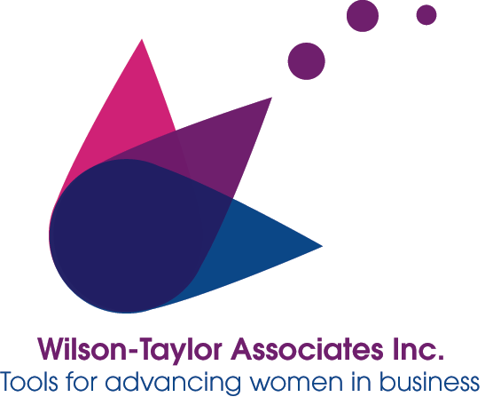Strategic communication firm Wilson-Taylor Associates, Inc., has been designing and managing national research projects that measure the progress of women in the workplace since 1998. Its methodology pivots on factors proven to remove barriers so that women can fully participate in driving business results. Led by veteran business journalist Joanne Cleaver, its current and past clients include Women in Cable Telecommunications, the Women's Transportation Seminar, the Alliance for Workplace Excellence, SitterCity, and many others. Please see Wilson-Taylor’s portfolio of work at [www.wilson-taylorassoc.com](http://www.wilson-taylorassoc.com/)

***MEDIA CONTACTS***

Joanne Cleaver

President  
Wilson-Taylor Associates, Inc.

980.224.8781 M: 414.232.3181

jycleaver@wilson-taylorassoc.com

Debi Williams

Director of Operations

Accounting & Financial Women’s Alliance

859-219-3578

[deborah.williams@afwa.org](mailto:%2520deborah.williams@afwa.org)

- END -