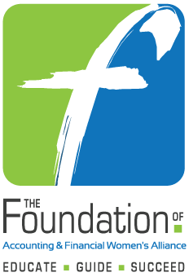

2017-2018 Undergraduate and Masters Scholarship Applications
Endorsement Form

Submit to The Foundation by
April 1, 2017, 5:00 pm Eastern Time

Select One:
Undergraduate Degree ⁭ Masters Degree

Name and Address:
Telephone Number: |  | Email address:
School/University:
CANDIDATE INFORMATION

ENDORSER INFORMATION
Scholarship Year: | 2017-2018 | Date:
Endorsing Chapter or Member:
Telephone Number: |  | Email Address:

Please provide a brief paragraph endorsing this candidate.

All submissions should be made in electronic format. The form can be submitted with the applicant’s scholarship form or separate. Email endorsement to foundation@afwa.org

