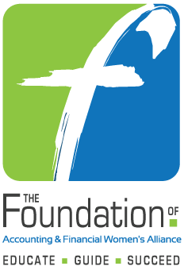
2017 - 2018 Certification Scholarship Application
AFWA Members Only

Submit to The Foundation by
November 1, 2018, 5:00 pm Eastern Time

PLEASE READ AND COMPLETE THIS APPLICATION CAREFULLY!!
ONLY COMPLETED CANDIDATE SUBMISSIONS WILL BE CONSIDERED.

Certification Scholarships
Purpose: To support the exam fees of any one of the following certifications: CPA, CFP, CFE, CIA, CMA or CVA.
Criteria: Scholarship awards are presented to AFWA members only. Candidates are those who have passed all parts of the exam during the 24 months prior to November 1, 2018 and are eligible for certification. Documentation is required.

1. APPLICATION INFORMATION
AFWA Membership (chapter or member at large)
Date Applicant Joined AFWA

Date of Scholarship Application
Name of Applicant

RETURN APPLICATION AND ALL ACCOMPANYING DOCUMENTS
ELECTRONICALLY DIRECTLY TO:

foundation@afwa.org

2. PERSONAL DATA (Contact information where applicant may be reached 11/1/18-6/30/19)
Address
City/State/Zip
Telephone E-mail Address

3. AFWA Activities (those that you have participated in)
☐ Meetings & Chapter Events ☐ Chapter or National Committees
☐ Local AFWA Conferences ☐ National & Regional AFWA Conferences

Please include any additional information regarding your AFWA participation and leadership

- ACADEMIC BACKGROUND (Post-Secondary Schools Attended – list most recent first)
College/University

From – To
Major | Grade Point Average – Overall
 | Grade Point Average – Accounting/Finance courses

College/University
From - To
Major | Grade Point Average – Overall
Hours Completed | Grade Point Average – Accounting/Finance courses

5. Certification Information
Exam Passed

Date Passed

- RESUME - Please submit a current resume.

- TRANSCRIPT - Unofficial copy of post-secondary education transcript and a diagnostic report of your passing exam score(s).

- ESSAY - Please submit an essay (150-250 words) describing your involvement with AFWA.

- The candidate understands that if selected she or he will be asked to provide a digital picture and sign a release so that The Foundation can publish the picture and brief biography of candidate. If required, a candidate may need to supply their Social Security Number for reporting purposes.

Winners will be notified by December 1, 2018 if the application is submitted to The Foundation by November 1, 2018. Please do not call or email requesting the status of your application. Application submission does not guarantee a scholarship.

